ERGONOMICS ANALYSIS – GENERAL
1 – PROVIDE BACKGROUND
Job/Task: Hydrant Operations | Date: 09/09/24 |  | Analyzed by: Troy T Walsh, LMCIT
Area/Dept/Location: City of Victoria | Project Number: N/A |  | Employee Name: N/A
Supervisor: Brady Lee, PW Director | Workstation: Utilities – Water System |  | Job Title/Task: Flushing Operations
2 – CURRENT MAJOR STEPS |  | 3 – ERGONOMICS ISSUES |  | 4 – SOLUTIONS
Step 1: Manually removing cap from fire hydrant  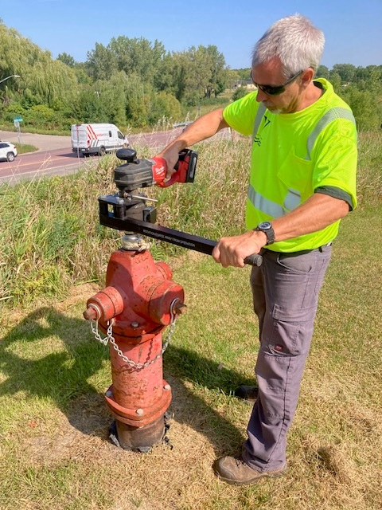 |  | Use of force when caps are stuck or hard to open. Many caps have never been opened, or maintained from original installation. |  | Utilzing mechanical advantage for cap removal.
Step 2: Open the fire hydrant to first flush the debris or sediment from the hydrant & watermain stem.  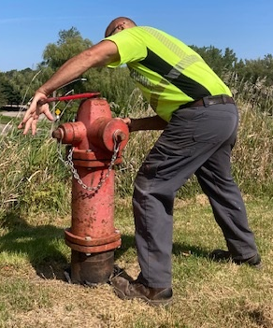 |  | The stance of the employee and force needed to manually open a fire hydrant. The pressure on the hand, arm, and body. This could be repeated up to 40 times per day during flushing operations. |  | Mechanical advantage to open/closing the hydrant is completed with a tool.  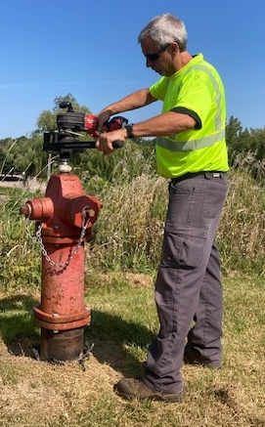
Step 3: Close the hydrant after flushing   |  | The stance of the employee and force needed to manually open a fire hydrant. The pressure on the hand, arm, and body. This could be repeated up to 40 times per day during flushing operations. |  | Mechanical advantage to open/closing the hydrant is completed with a tool.
Step 4: Connect a diffusion device to the hydrant for flushing operations. |  | There are different devives for different needs/applications. Manual moving of the hose and repetitive motion of the threded connection.  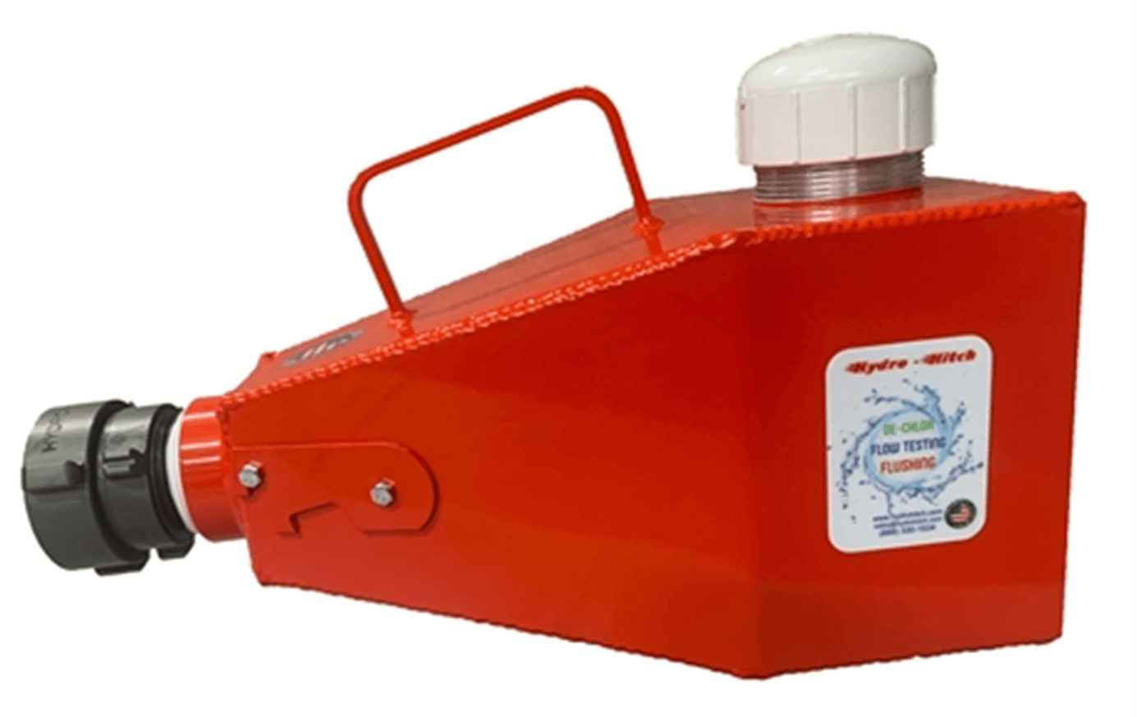 |  | Storz connection or quick connection for fire hydrant. Storz connections are locking quarter turn vs. a threaded multiple turn connection  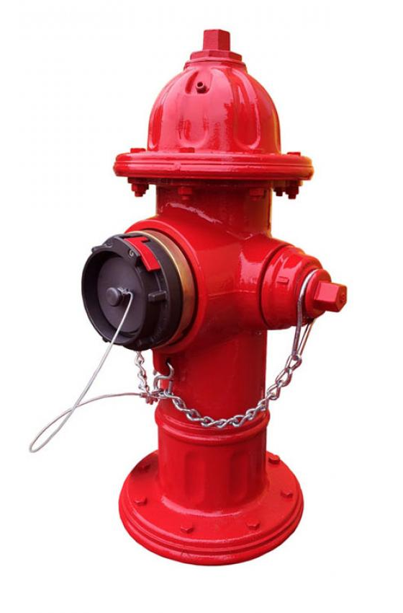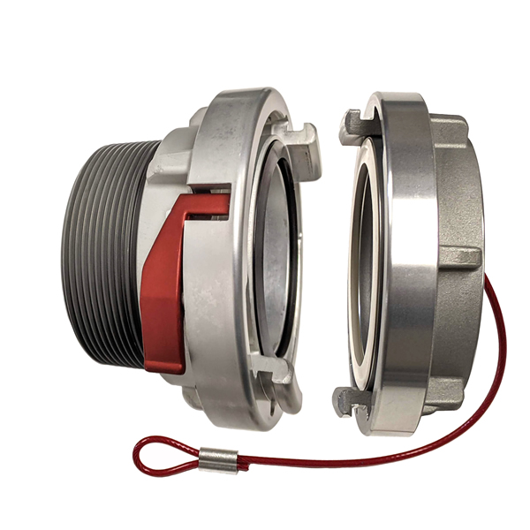
Step 5: Open Hydrant for flushing. This could be up to 16-20 rotations for each hydrant.  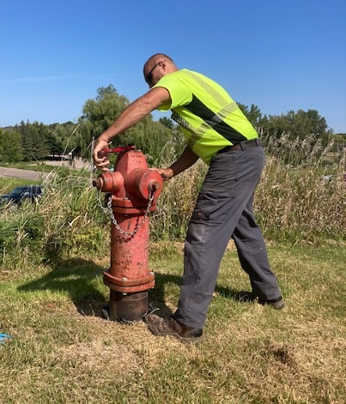 |  | Typical 6” Watermain Hydrant stem is 16-20 rotations, and larger hydrants could be additional rotations. This could add additional body muscle stress when the hydrant is not maintained or is difficult to operate.  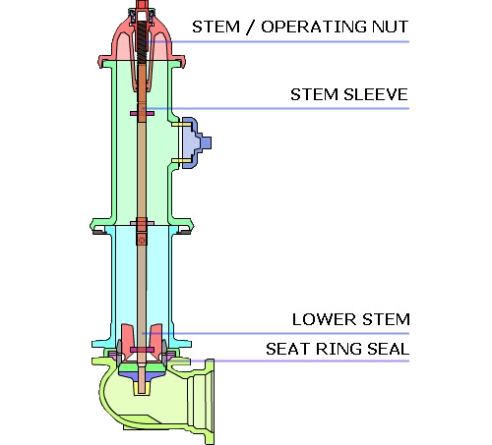 |  | Mechanical advantage to open hydrant for flushing. This could be up to 16-20 rotations for each hydrant  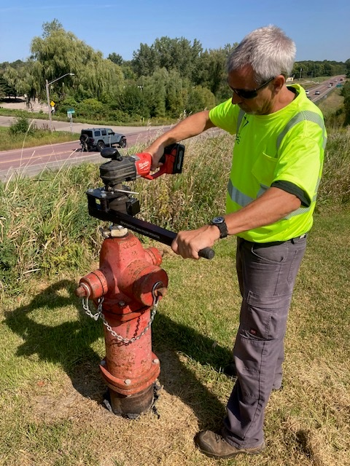.
Step 6: Complete hydrant flushing  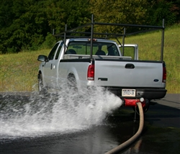 |  | N/A |  | N/A
Step 7: Once completed close the fire hydrant. This could be up to 16-20 rotations for each hydrant.  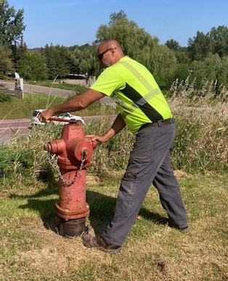  Step 8: Once the hydrant has properly drained, replace the hydrant cap and keep hand tight.  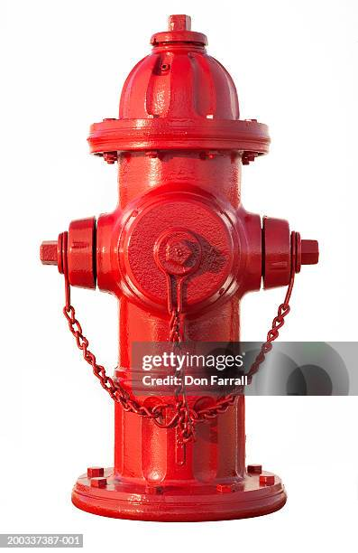 |  | Typical 6” Watermain Hydrant stem is 16-20 rotations, and larger hydrants could be additional rotations. This could add additional body muscle stress when the hydrant is not maintained or is difficult to operate.  N/A |  | Mechanical advantage to close hydrant after flushing. This could be up to 16-20 rotations for each hydrant  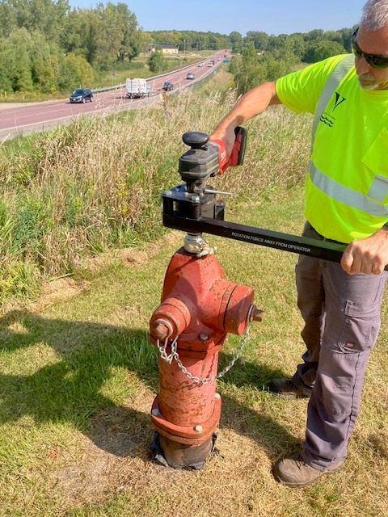  N/A

5 - FOLLOW UP

