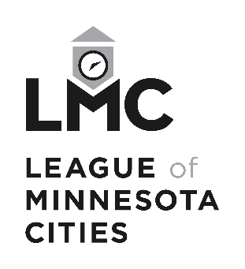

Property Claim Form

League of Minnesota Cities Insurance Trust (LMCIT)
Send To | LMCIT Claims  145 University Ave W  St. Paul MN 55103-2044 | Phone  Fax | (651) 281-1287  (800) 925-1122  (651) 281-1297
 |  | Email | claims@lmc.org

Contact Information

Today’s Date

Member (City / Entity) Name

Member (City / Entity) Address (Street, City, State, Zip)

Contact Person

Contact Person Phone Number

Covenant Information

Covenant Number (if known)

Covenant Period (if known)

Name of and/or Description of Damaged Property

Loss Information

Date of Loss

Time of Loss (am/pm)

Reported Previously?

Location of Loss

Estimated Amount of Loss

Description of Loss

Additional Information / Comments

Signature

Reported By

Signature

Date

