Employee Incident Report

Complete this form and return it to your supervisor immediately.

Employee Information

Employee Name (Last, First, Middle)

Date of Birth

Employee Home Address (Street, City, State, Zip)

Phone Number

Job Title

Department

Supervisor

How long employed?

Incident Information

Date of Incident

Time of Day

Day Occurred

Location of Incident

Who did you notify of this incident?

Describe exactly what happened and how the incident occurred. Include details such as equipment, environment, work location, work tasks, and so on.
Indicate on the diagram the location of your injury(ies). | 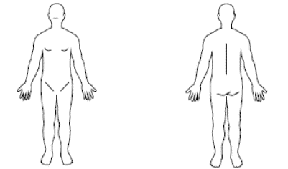

Was first aid administered? If yes, when? By whom?

Did you go to the hospital? If yes, when? Where?

Did you go to the clinic? If yes, when? Where?

Did you see a physician, chiropractor, nurse practitioner or seek other medical attention? If yes, when? Who did you see? Where?

Do you intend to seek additional medical care for this injury?

Who witnessed the incident?

How much time did you miss because of the incident? If time was missed, when?

What actions do you intend to take to avoid this in the future?

Do you have other regular employment?

Additional Information / Comments

Signature

Employee’s Signature

Date
ANY PERSON WHO, WITH THE INTENT TO DEFRAUD, RECEIVES WORKERS' COMPENSATION BENEFITS TO WHICH THE PERSON IS NOT ENTITLED BY KNOWINGLY MISREPRESENTING, MISSTATING, OR FAILING TO DISCLOSE ANY MATERIAL FACT IS GUILTY OF THEFT AND SHALL BE SENTENCED PURSUANT TO SECTION 609.52, SUBDIVISION3, MNWC STATE STATUTE 60A.955.

