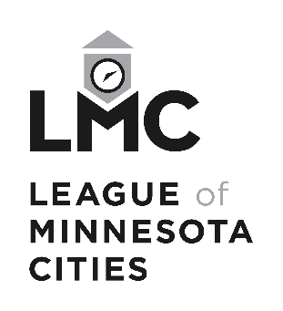

Automobile Claim Form

League of Minnesota Cities Insurance Trust (LMCIT)
Send To | LMCIT Claims  145 University Ave W  St. Paul MN 55103-2044 | Phone  Fax | (651) 281-1287  (800) 925-1122  (651) 281-1297
 |  | Email | claims@lmc.org

Contact Information

Today’s Date

Member (City / Entity) Name

Member (City / Entity) Address (Street, City, State, Zip)

Contact Person

Contact Person Phone Number

Covenant Information

Covenant Number (if known)

Covenant Period (if known)

Accident Information

Date of Accident

Time of Accident (am/pm)

Reported Previously?

Description of Accident

Insured Vehicle Information

Year

Make

Model

VIN

Driver’s Name & Job Title

Phone Number

Estimated Damage Amount

Description of Damage

Other Vehicle / Property Damage Information

Year

Make

Model

VIN

Owner’s Name & Address (Street, City, State, Zip)

Phone Number

Driver’s Name (if different from owner)

Phone Number (if different from owner)

Any Insurance? (If yes, provide company, agent name, & phone.)

Estimated Damage Amount

Description of Damage

Bodily Injury Information

Injured Person’s Name & Address (Street, City, State, Zip)

Phone Number

Description of Injury

Additional Information / Comments

Signature

Reported By

Signature

Date

